**Assignment 24.4**

**Creating Table and Loading data**

**Created table titanic_data and loaded Data**

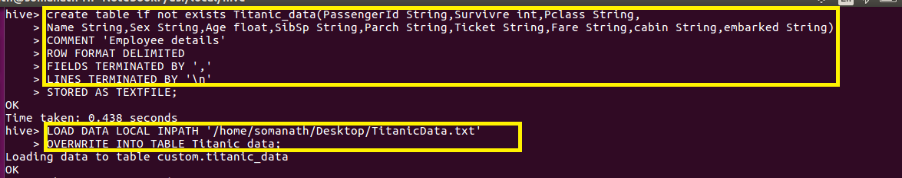

1. **Write a hive query find the average age of male and female persons died in the titanic tragedy. Find average age using avg() function filter by dead and grouped by sex as shown.**

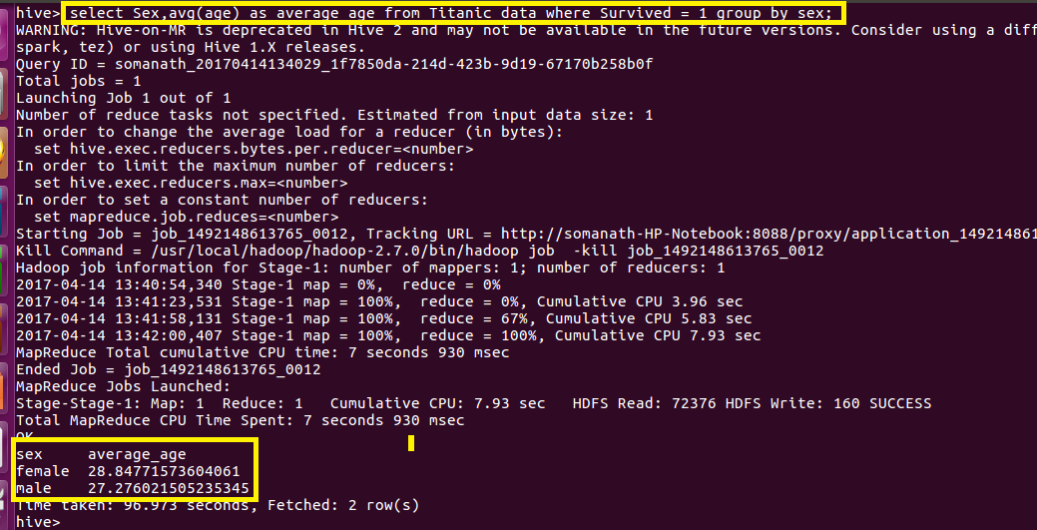

1. **Write a hive query to find the number of people died and survived in each class. Since we want number of people died and survived in each class I grouped by pclass and survived**

